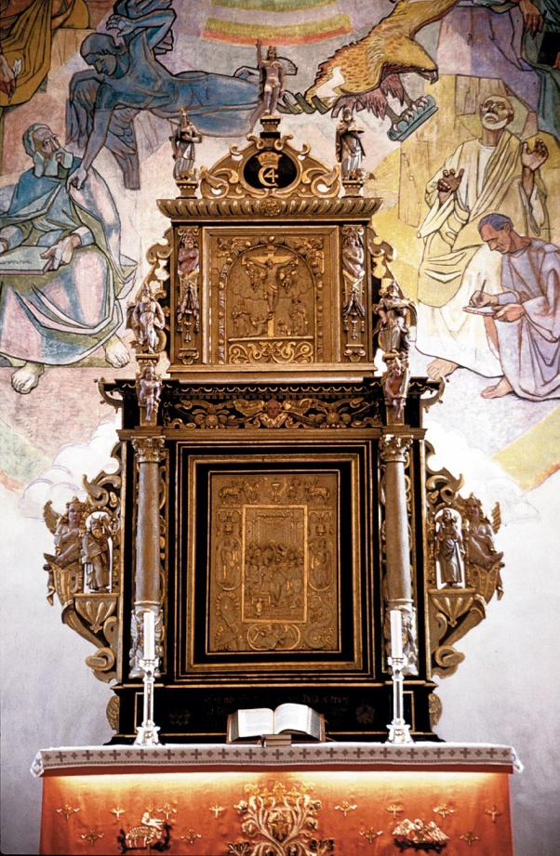
The altarpiece
The altarpiece is a costly treasure, carved by Johan Reinholt in 1633.
The lower part shows the scene of the Last Supper surrounded by Communion symbolism: under, the pelican which pecks itself to feed its offspring with its blood; further, the bread, wine, eaves of corn and grapes; and over, the lamb of victory. On the sides and underneath are three female figures, representing Faith, Hope and Love.
The upper panel shows the Crucifixion scene. It is supported by two angels standing on Hellenic columns, wreathed with acanthus and the crowing cock - symbols for the torture of body and soul. The women beside the cross hold bowls for collecting the drops of blood from the suffering Christ.
The top of the altarpiece is crowned by the victorious and resurrected Christ, surrounded by the four evangelists.

The organ gallery
Lastly, we turn to the gallery and the shining cross above the organ pipes. This is the inner meaning both for this church and every church service. The hope and light of our daily lives.

The four carved figures on the gallery rail are an inherent part of church history. They represent Ambrosius, Luther, Hans Nilsen Hauge and Landstad.

Thank you for visiting Ullensaker church! Welcome back!

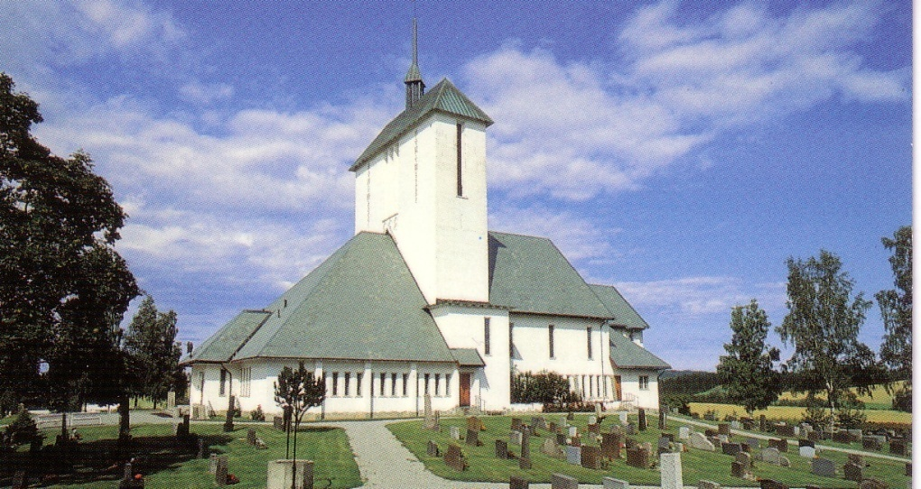

Welcome
to
Ullensaker church!

The site on which Ullensaker church stands today has been church ground for hundreds of years. The church now standing is the fourth in a series of Christian churches. However, in the days before Christianity the site was also a place of worship dedicated to the Norse god of sports and winter games, Ull.

The first church we know of was built in the late 12th century. Built of stone, it stood for about 400 years, until about 1475 when it was destroyed in a landslide.
The second church was a stave church which stood for about 300 years, until 1768 when it was torn down.
The third church was also built of wood - a timber cross-shaped church. It stood for almost 200 years, until 1952 when it was destroyed by fire.

The present Ullensaker church, which was inaugurated in the autumn of 1958, was designed by Arnstein Arneberg. He was heavily influenced by the history of the church and wished to recreate all the previous churches in the new one, at the same time making it a symbol of mankind's yearning towards God. He has in a masterly way been successful in recreating all this in one building.
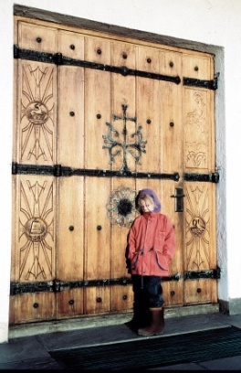
Here we see the low-walled building from the Viking era combined with the monumental and roman stone church, the stave church shape and the timbered cross church, depending on the angle from which the church is observed.

Before going inside, take a look at the main door, which is beautifully decorated with wrought iron and symbolic wood carving. The door ring dates from the 12th century.

The frescoes
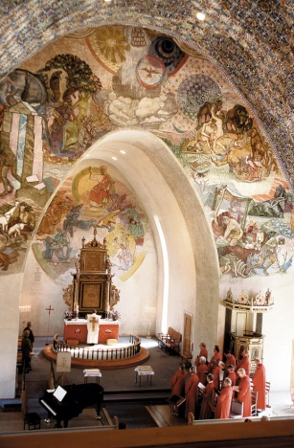
Inside the church we notice the splendid decorations created by Alf Rolfsen. He has taken up the theme from the altarpiece and magnified it on the east wall, where the victorious Christ sits enthroned, surrounded by the four evangelists with their attributes.

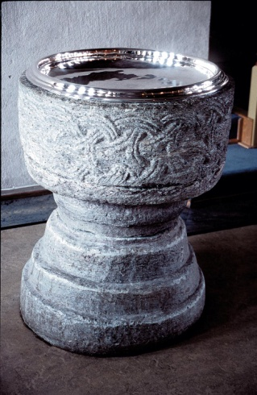
On the wall in front of the chancel we find the symbol of Trinity at the apex of the arch and below this are scenes from the Garden of Eden - the immaculate. Yet here we also see how man rebels against God and how he sinks to the lowest degradation - that of fratricide. On the opposite side are scenes from daily labour and we are reminded of the words "By the sweat of your face you shall eat bread". However, it also shows the fruit of labour contrary to degradation.

The north wall shows a very well-known theme: "As a deer pants for flowing streams, so pants my soul for you, O God". This is deeply symbolic and yet clearly expressed. From the north - darkness and the greatest distance from God, we yearn for him who is our Father.

The south wall, which has no painted scenes, has instead three high lead windows with different motifs:
The first window shows the lamb with victory banner under a crown, witnessing the victory of Jesus over sin and death.
The second window shows the vine which is a symbol of Christ.
The third window shows a dove bearing an olive-branch - a symbol of peace.

Above all this in the arched ceiling Rolfsen has recreated the mighty and eternal heavenly stars - infinite in depth and magnitude. Again, a picture of God's greatness and power.

The pew ends
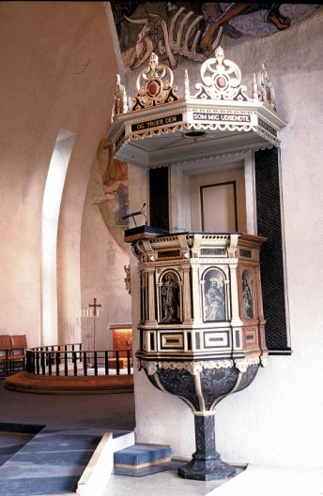
On each side of the central aisle the ends of the pews are decorated with five motifs which are repeated: the Angel with halo - the Ship - The Cross - the symbol of Faith, Hope and Love - and the Star of David.

The pulpit
The pulpit, on the right hand side, was built in 1649. It was painted by the well-known priest and commander Kjeld Stub. The panels show Christ and the four evangelists. The panel showing John the Baptist has not been restored, but shows the original work of Stub. It is masterfully alive, almost impressionistic.

The Christening font
On the left stands the font, between the main part of the church and the chancel. This font, like the ancient door ring on the main door, are among the most precious possessions of the church. They are both from the 12th century. The font is made from soapstone. The ornamentation is very old and shows affinity with the oldest Norse times. At the same time it bears the mark of Christian eternity.

